# APIs with Power BI and Other Advanced Techniques

1. Getting an API key

Website: - <https://openweathermap.org/>

Open the Website and Click on API.

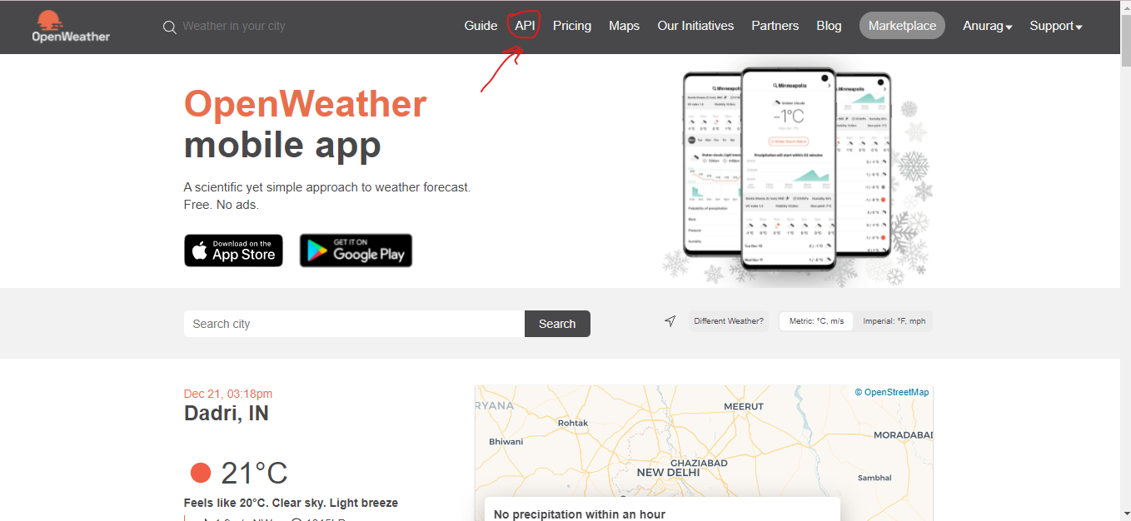

We Will Going to Use One Call API As we can get Minute, Hourly, Daily, Forecast and Historical data and many More.

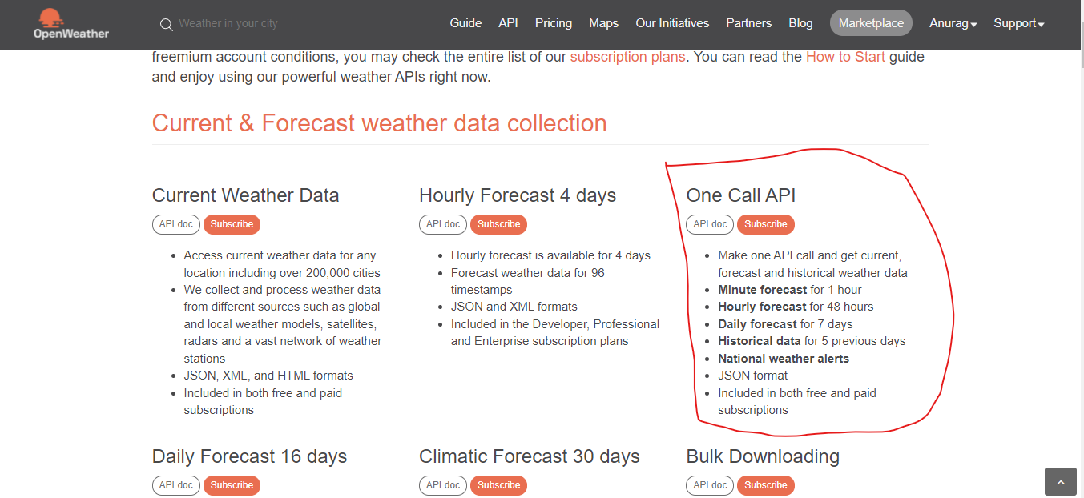

Click On Subscribe and Choose the Free Option Available and then Sign up to get the key your API Key.

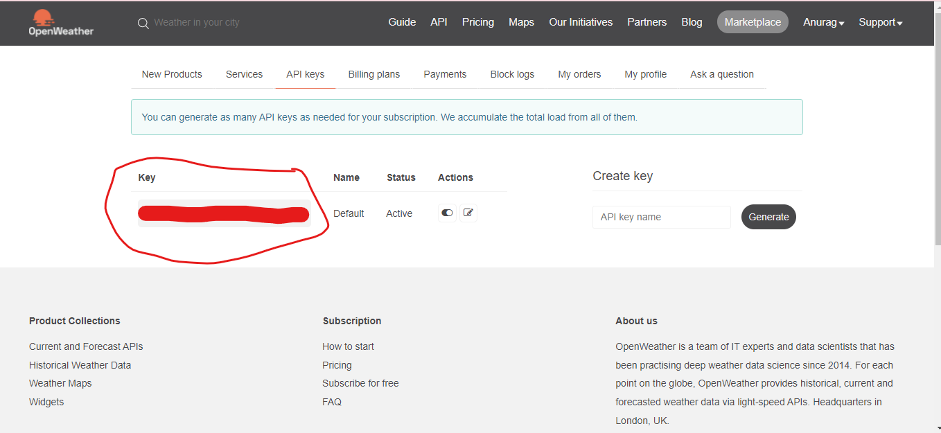

1. API Overview

Click On the API docs available aside subscribe Button.

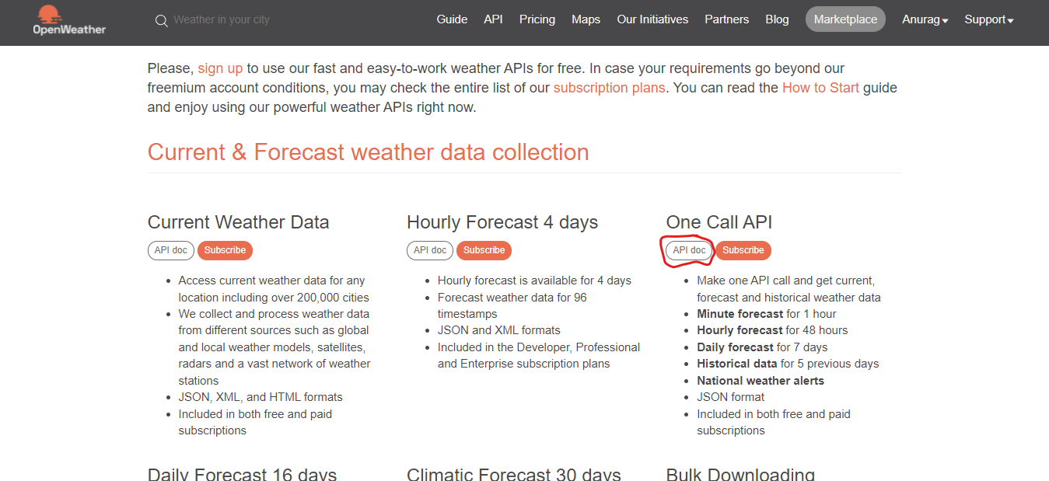

This API document Contains all the Parameter Available in an API.

Like How To Call API What are the Parameter.

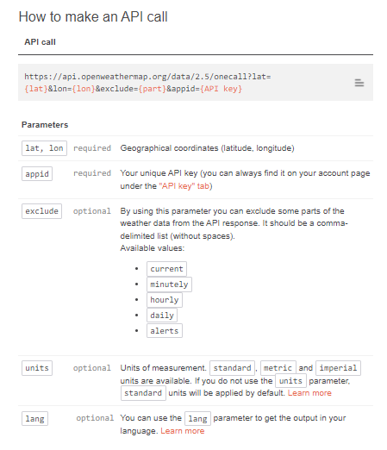

Build an API Call

Copy The Above Link i.e., https://api.openweathermap.org/data/2.5/onecall?lat={lat}&lon={lon}&exclude={part}&appid=[{API key}](https://home.openweathermap.org/api_keys)

Breaking above link into Base URL and parameters

<https://api.openweathermap.org/data/2.5/onecall> :- Base URL

**Parameters**

To Identify from Where Parameters are Starting in URL is

First Parameter Start With an **?**

And others Parameter Start with **&**

Now Parameters in this API are

?lat={lat} Latitude of the Location for which weather data is Needed

&lon={lon} Longitude of the Location for which weather data is Needed

&exclude={part} This is a Parameter in which we can exclude Some data of Weather and List of Data That we can Exclude are:

Current, Daily, Hourly, Minutely and alerts

&appid=[{API key}](https://home.openweathermap.org/api_keys) Key of an API

&unit=[{unit}](https://home.openweathermap.org/api_keys) Its an Optional Parameter in which You can use Choose the units of Measurements that are **imperial, Standard, metric** and by Default it will be Standard.

&lan=[{language}](https://home.openweathermap.org/api_keys) You can Choose the Language if you want it’s also an Optional Parameters.

So we Will be Creating our link with parameter Details Filled in it with an api key

**https://api.openweathermap.org/data/2.5/onecall?lat=22.78 &lon=78.20&exclude=minutely&units=imperial&appid=Enter your API Key**

1. Importing API into Power BI

Open Power Bi Desktop Application and Click on Get Data and Choose the Web and paste the Above Link in it to Connect with the API.

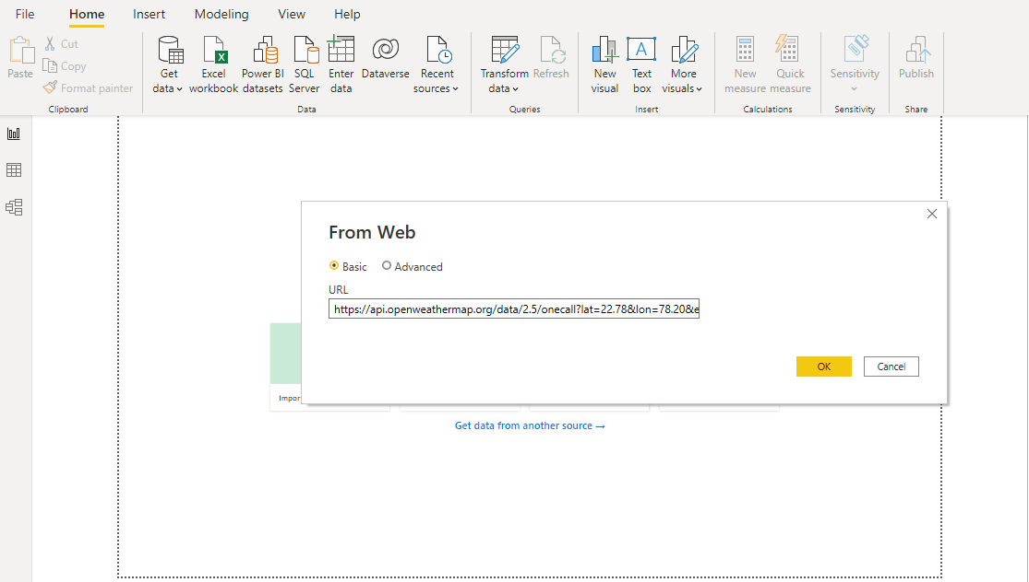

Once You Will be Connected to API You Will Get Some Sort of Data

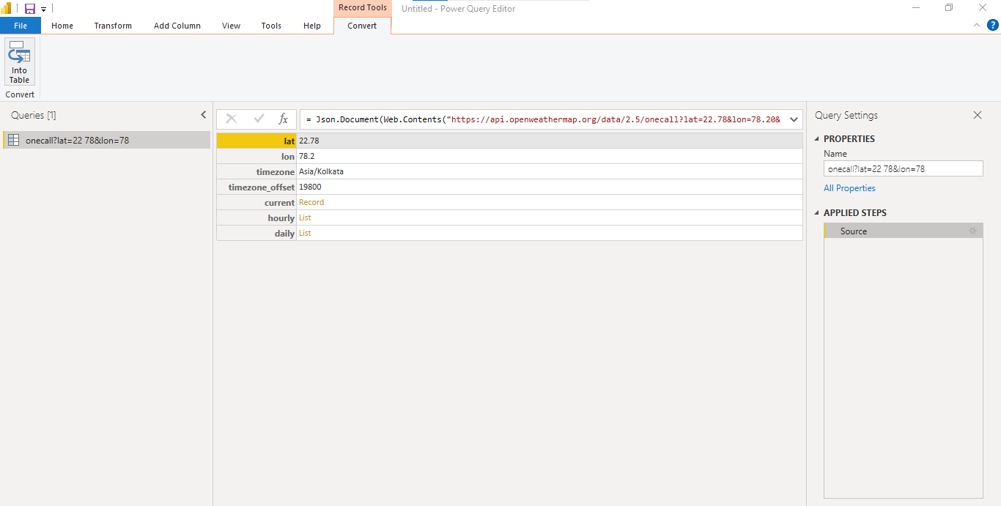

Now we Will Create Our Connection String Using Parameters.

Click on Home and Choose Manage Parameters

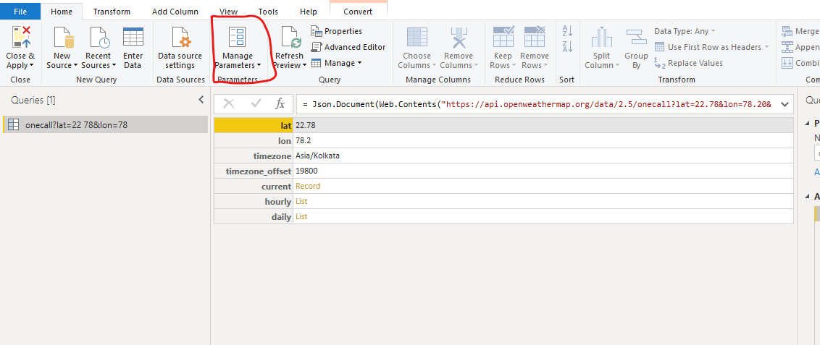

You can Rename the Query name by Main Query for Easy Understanding.

Now Click on New and we will Create Parameters

Firstly, we will Create Parameters for Latitude

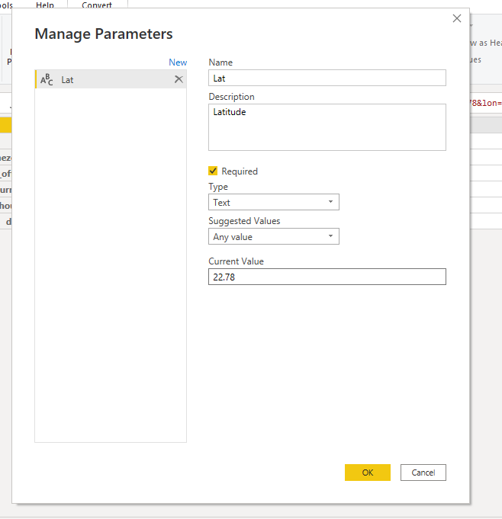

Now We Will Create Parameter for Longitude

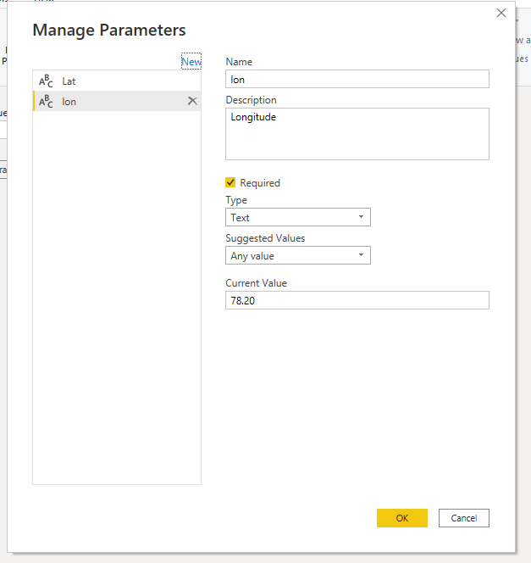

Now We Will Create the Parameter for Exclude

In This We Will Choose the List Option in Suggested Value as we have Current, Daily, Hourly, Minutely and alerts Options.

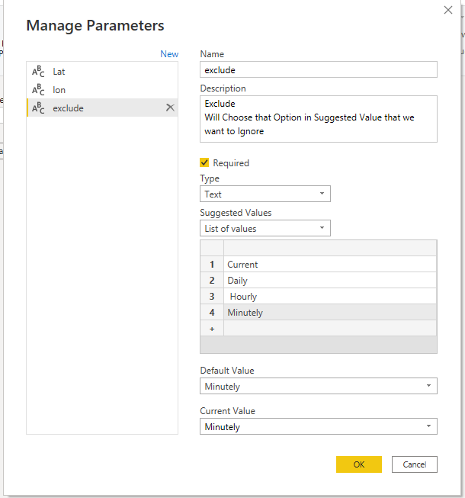

It Will Exclude the Minutely Data.

Parameter For Units

Choose Either You want you Measurement in Imperial or Metric

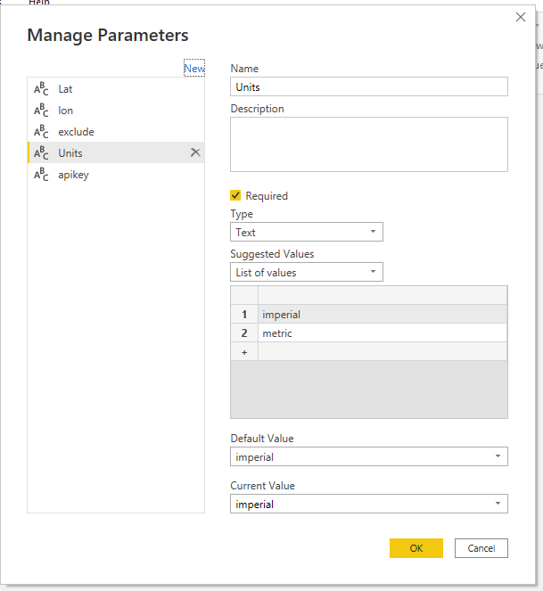

Parameters For API Key

Enter you API in Current Value

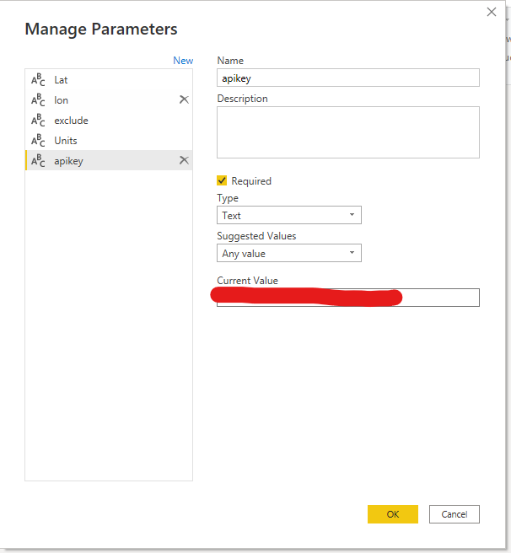

Now All the Parameters are Created Now we Will be Configure our connection String.

Click on the Setting Button Near Source in Applied Steps.

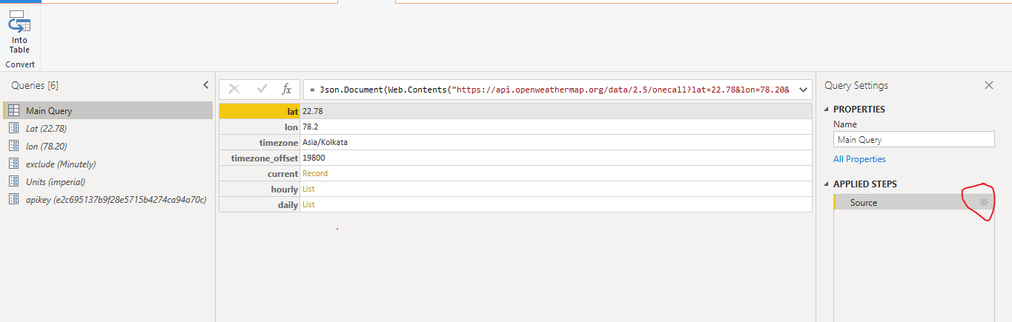

Once You Click on the Setting Button an Pop up Will Come Choose Advance Button.

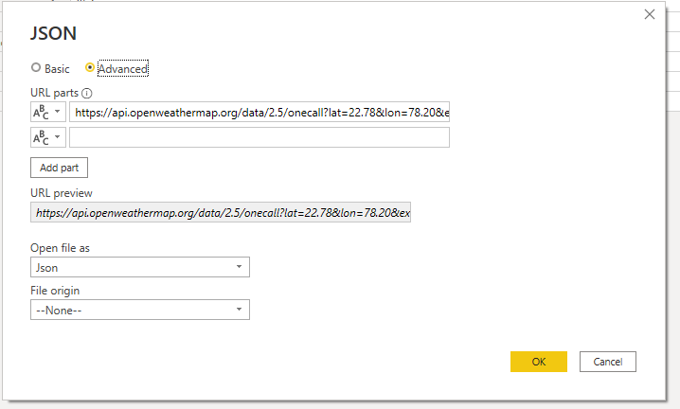

Now We Will Pass Our Parameters Here Shown Below

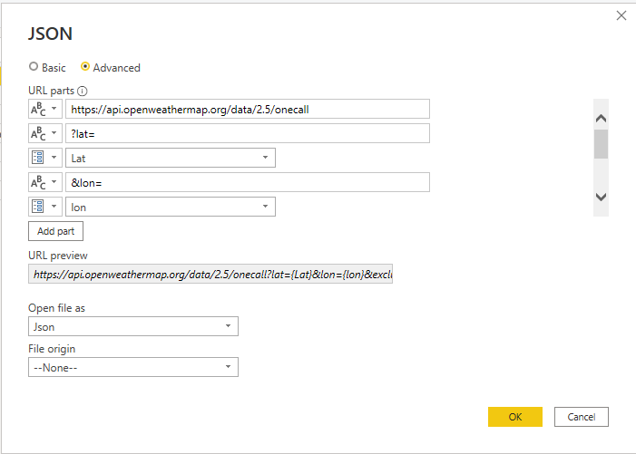

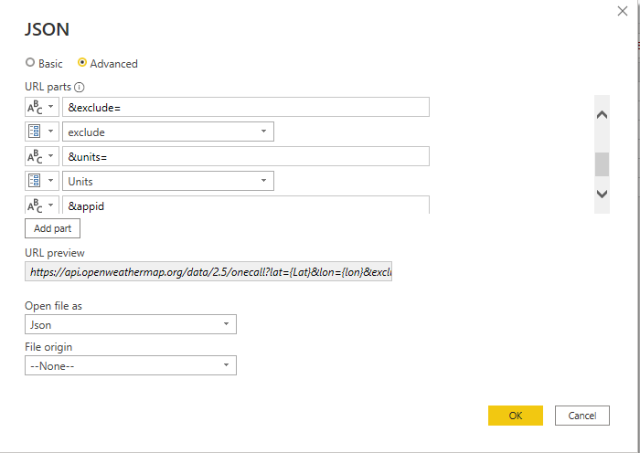 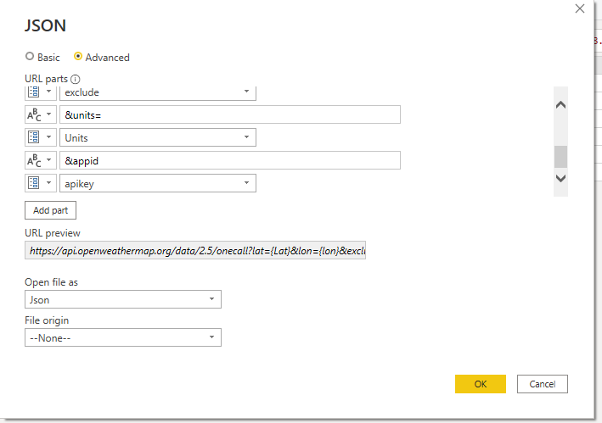

Click on Ok

Now We Will Fetch The Data From this Json Format.

Now Click on the Convert into Table in Convert Menu.

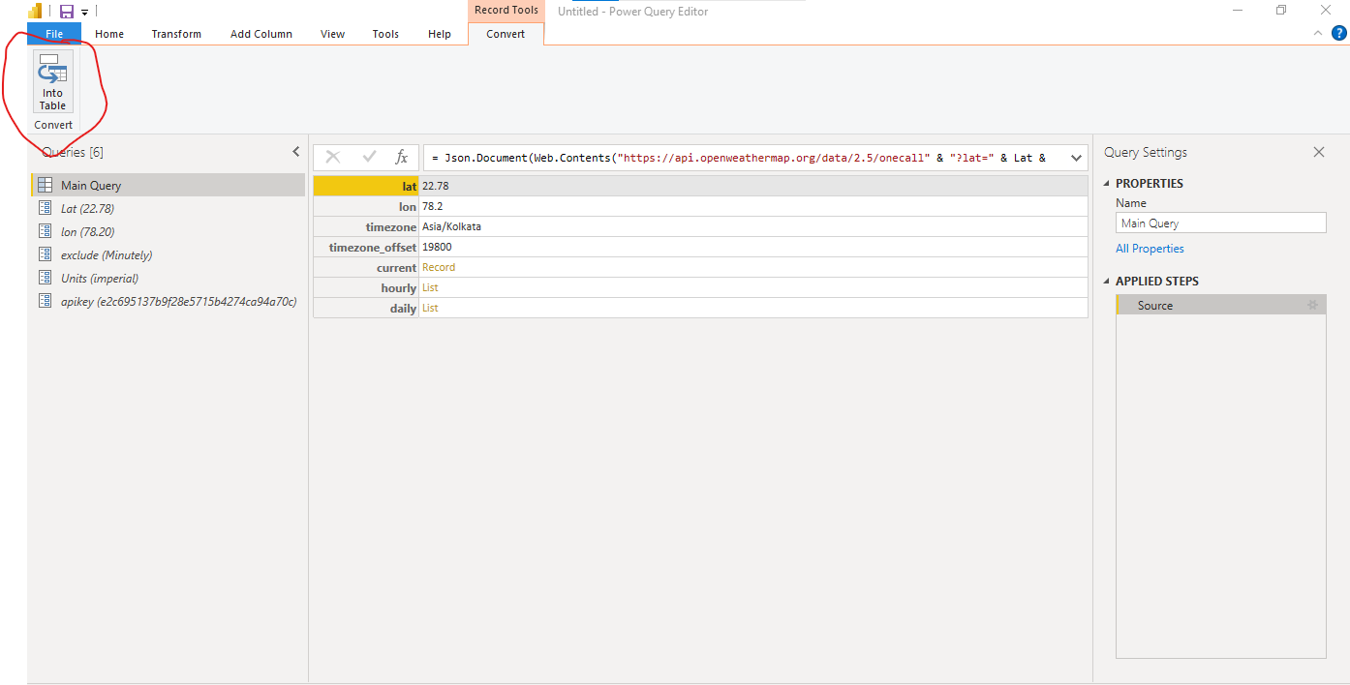

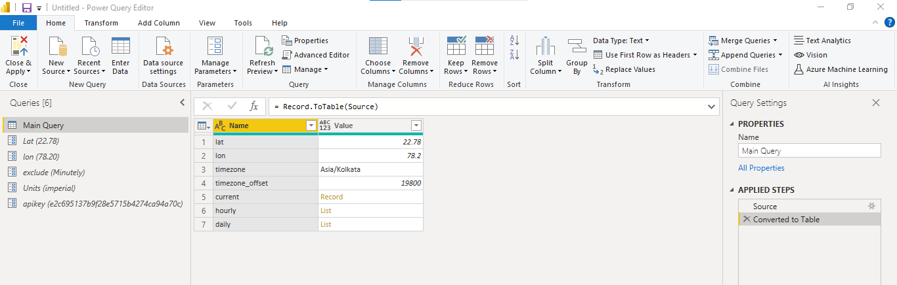

Now in We Will Apply Data Modelling to Convert Raw data into meaning Full Data.

For this Firstely We will Transpose the Name column and Then in Home Tab We will Choose Make First Row as Header.

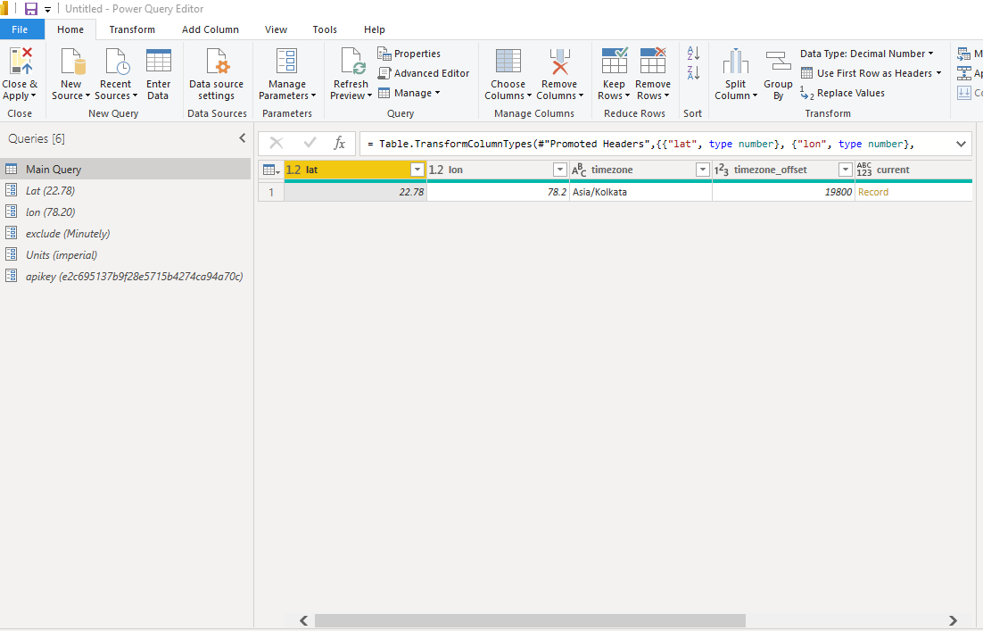

Now in Current Column We have Records Right Click their and make Add as new Query.

Now Click on Convert into table and again Transpose it and Choose First Row as Header

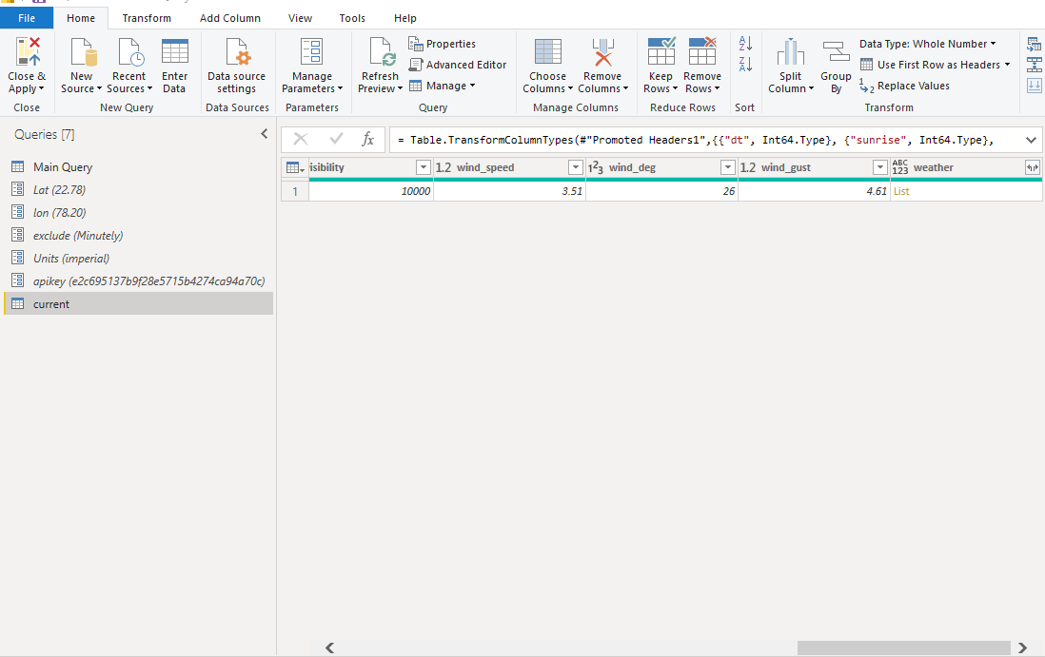

Now in Current Table We have Column Weather Expand this to New Column.

Now Come Back to Main Query and Right Click on Hourley Column and Convert it into Table.

Expand All Columns

Perform All Data Modeling and then Close and Apply.